**FIBONACCI SERIES WITHOUT RECURSION:**

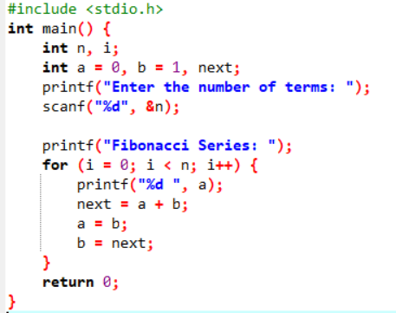

OUTPUT:

